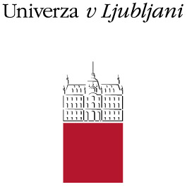
University of Ljubljana
Kongresni trg 12
1000 Ljubljana
Slovenia
Tel. + 386 1 2418 590
Fax. + 386 1 2418 593
e-mail: intern.office@uni-lj.si
http://www.uni-lj.si

INVITATION TO

INTERNATIONAL STAFF EXCHANGE WEEK

AT UNIVERSITY OF LJUBLJANA

APRIL 16-20, 2012

REGISTRATION FORM
Family name
First name
Title/position
Contact address

Email
Telephone/Fax
Name of the University/Department
Please choose your preference for department visit on April, 18 (Wednesday) | - Career Centre  - Research office and EU projects  - 1st, 2nd or doctoral degree cycle  - Accountants office  - Librarians office  - Public relations office  - Computer centre  - International relations office
Please choose which Faculty would you like to meet ( for individual meeting) on April, 19 (Thursday)
Will you participate on trip to Postojna caves on April, 20 (Friday) | - Yes  - No
Arrival and departure dates

Date: Signature: (information can also be sent by email)

University of Ljubljana Tel . + 386 1 2418 590
Kongresni trg 12 Fax + 386 1 2418 593 Internet: http://www.uni-lj.si
SI- 1000 Ljubljana

